**Tutorial 2 - Class Diagrams**

**(You have to draw all diagrams in starUML tool)**

1.Create a class diagram for the Banking system.

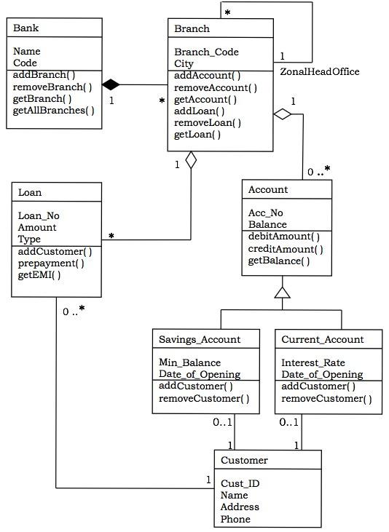

2.Create a class diagram for the School Management System.

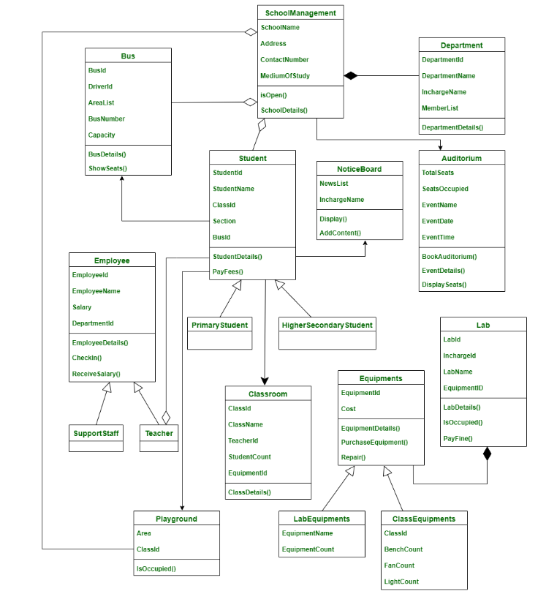

3.Create a class diagram for the library management system.

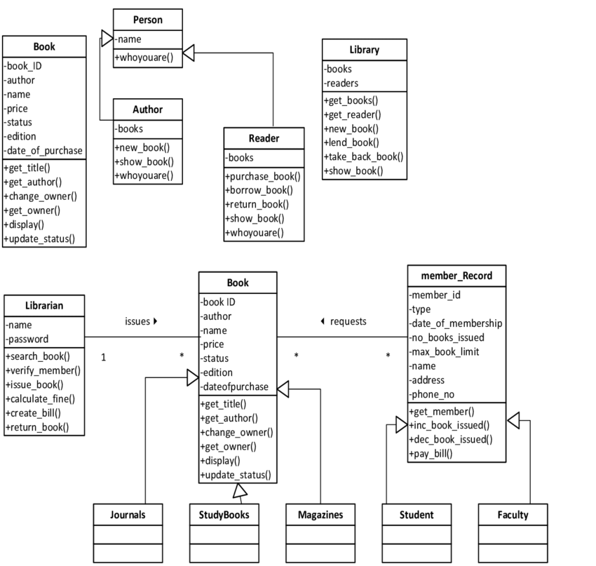

4.Represent the ATM system in the class diagram.

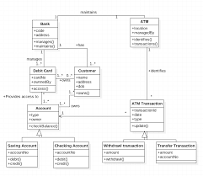

**Tutorial 3 - Use case diagrams**

* **1.**Create Use case diagram for library management system.
* 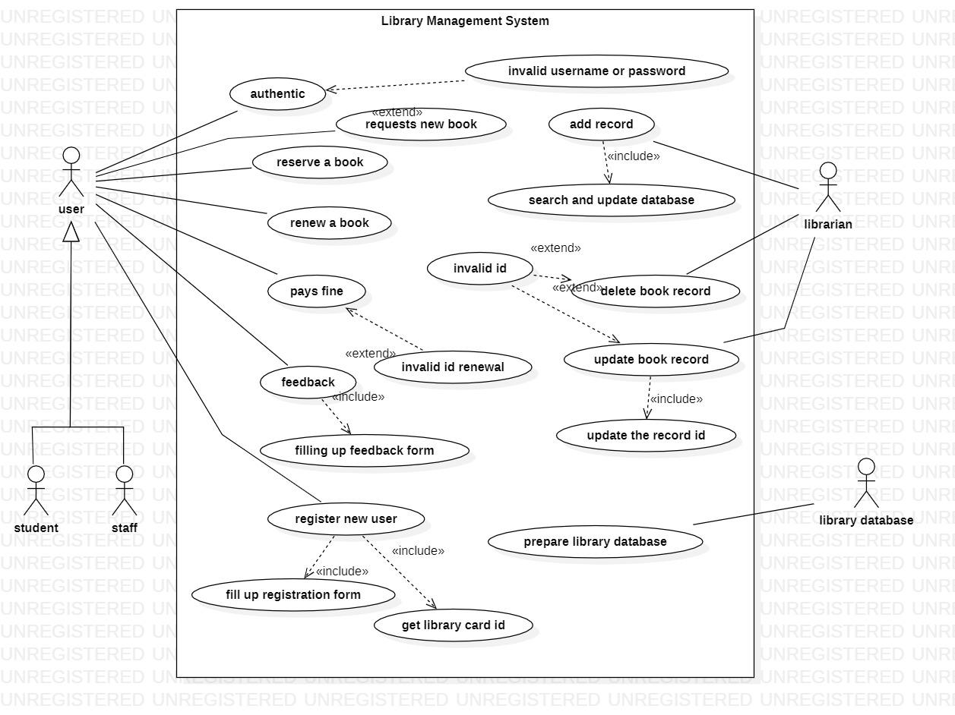
* **2.**Create Use case diagram for online shopping system.
* 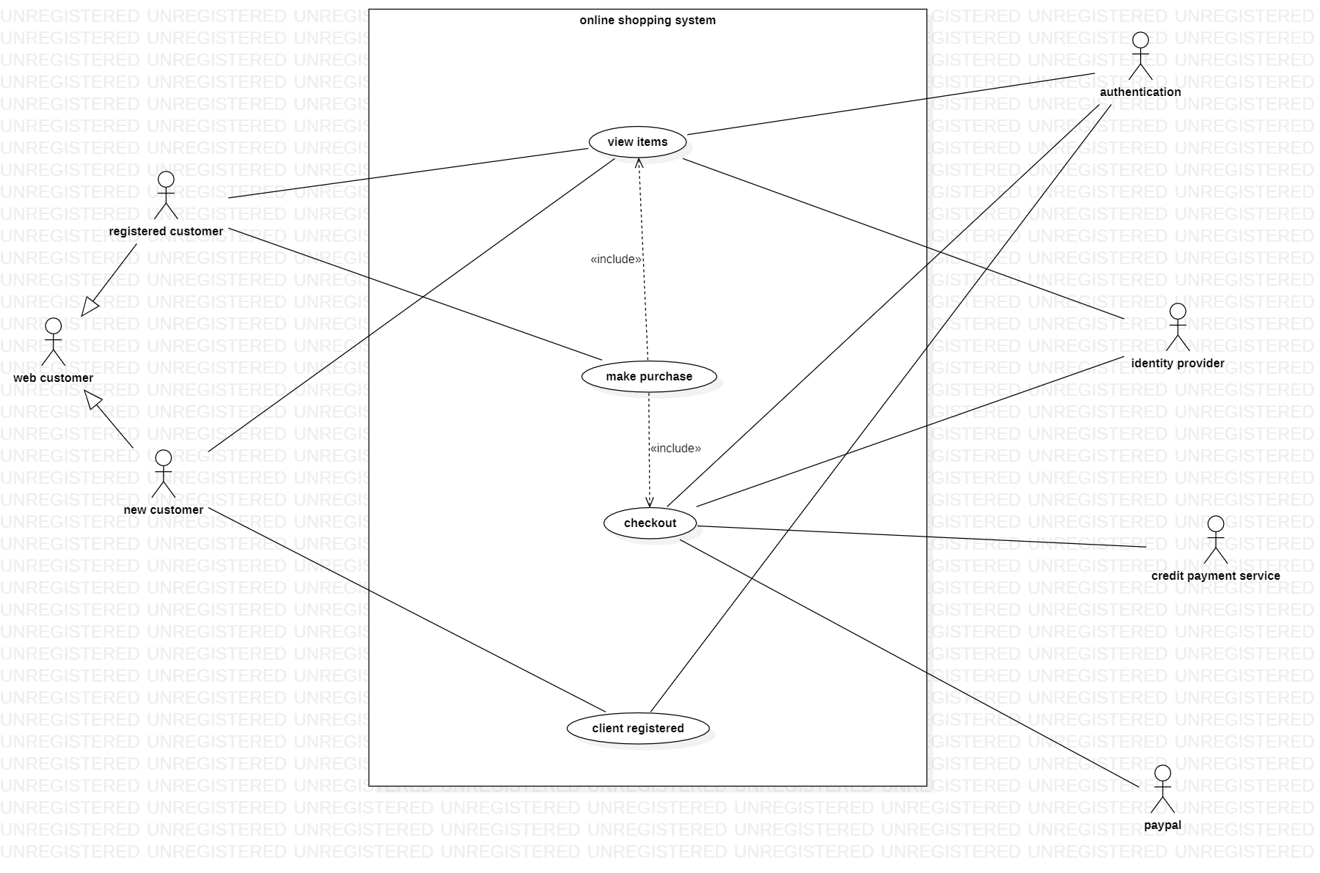
* **3.**Create Use case diagram for ATM system.
* 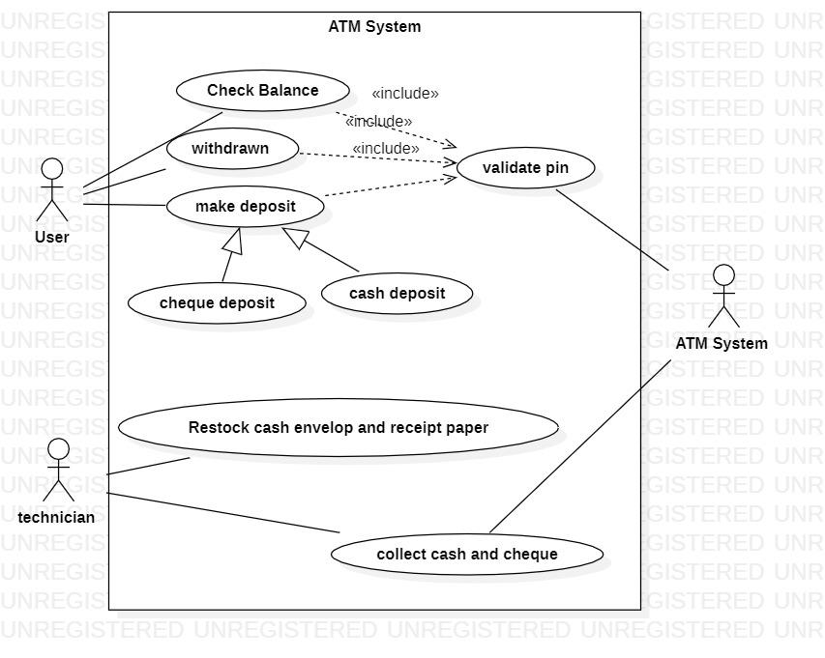
* **4.**Create Use case diagram for Banking system.
* 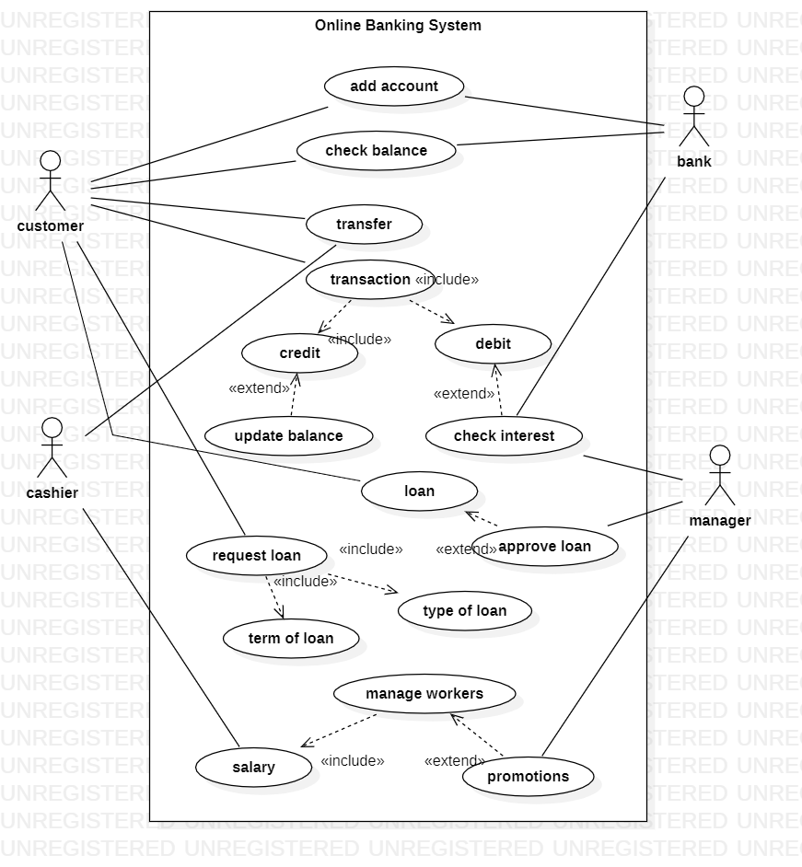

**Tutorial 4 - Activity diagrams**

**(You have to draw all diagrams in starUML tool)**

1. Create an activity diagram for Student Enrollment System in University

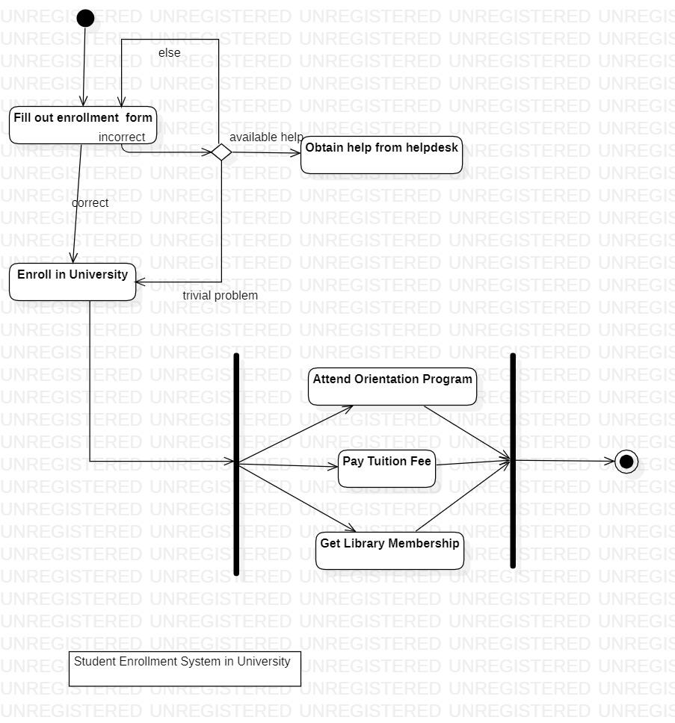

1. Create an activity diagram for the Stock Trade Processing system.

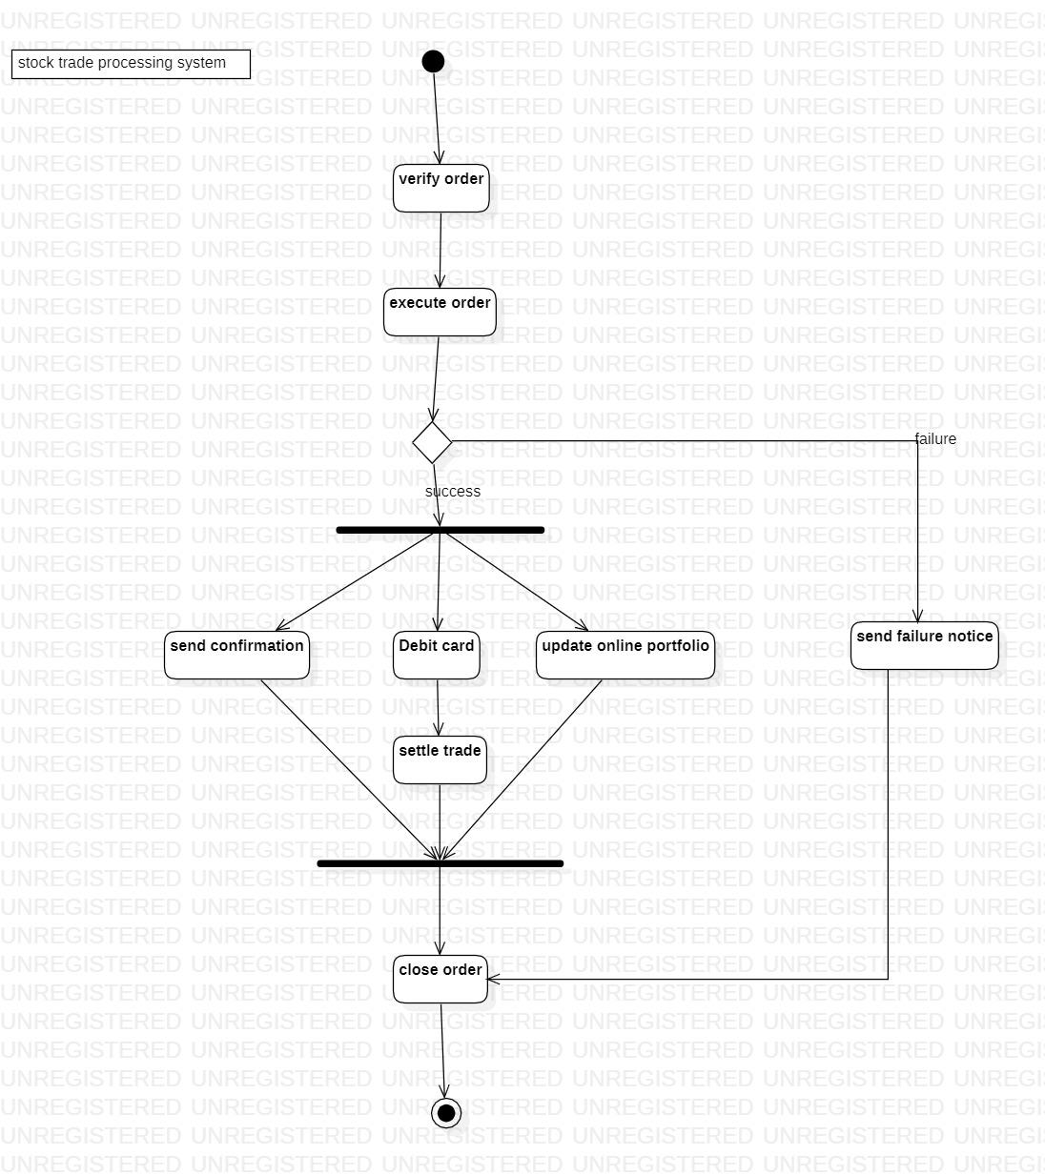

1. Create an activity diagram for the ATM system.

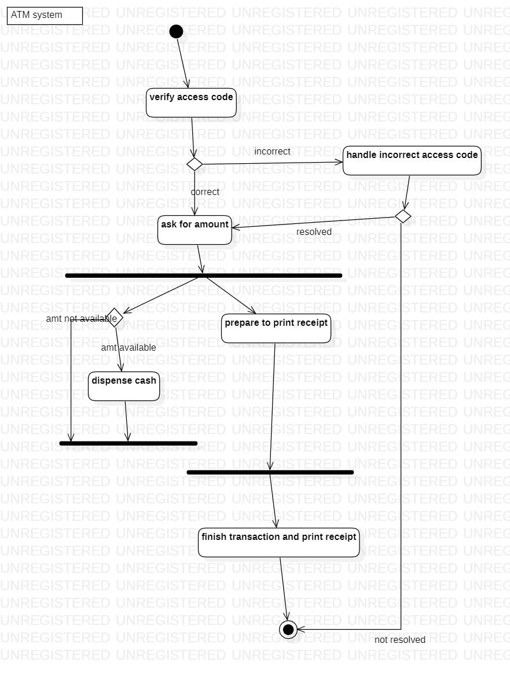

1. Create an activity diagram for LMS.

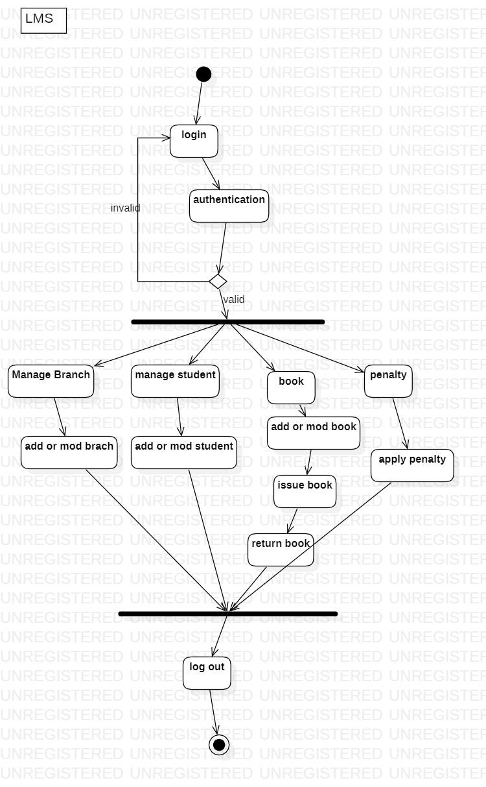

**Tutorial 5 - Sequence diagrams**

**(You have to draw all diagrams in starUML tool)**

**Draw sequence diagrams for following system**

1.Student Management System.

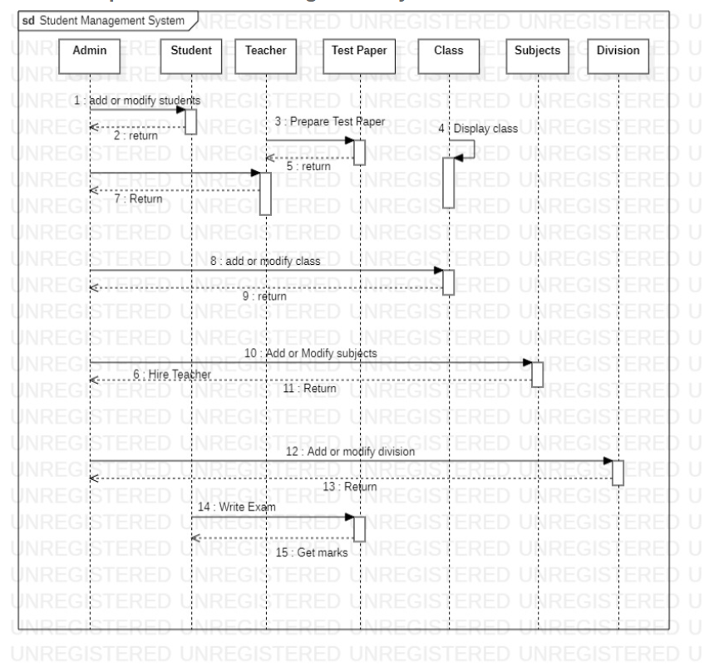

2.Online shopping System.

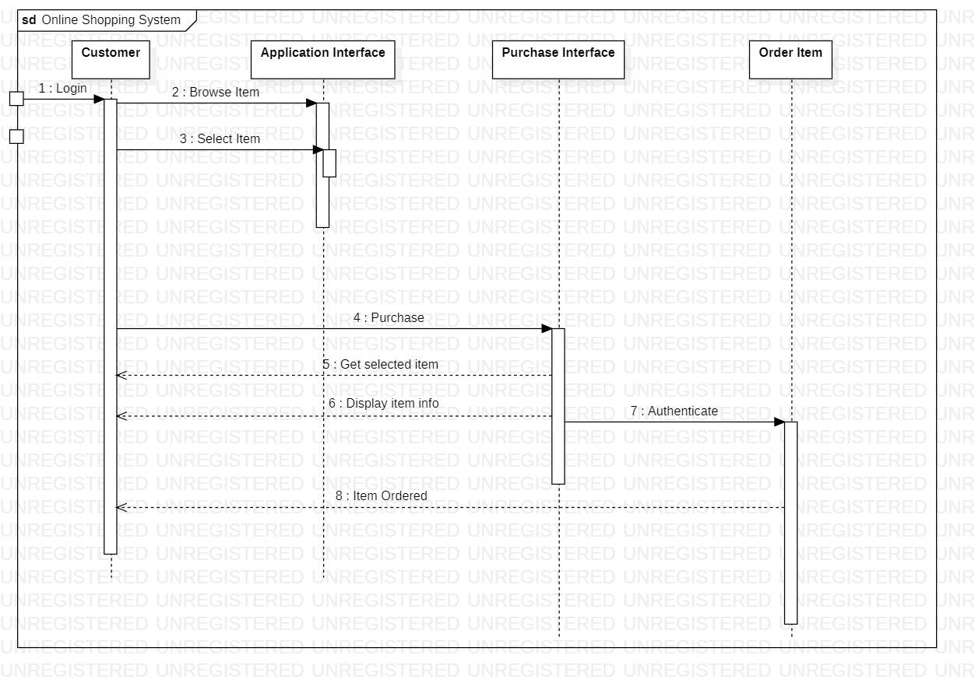

3.LMS.

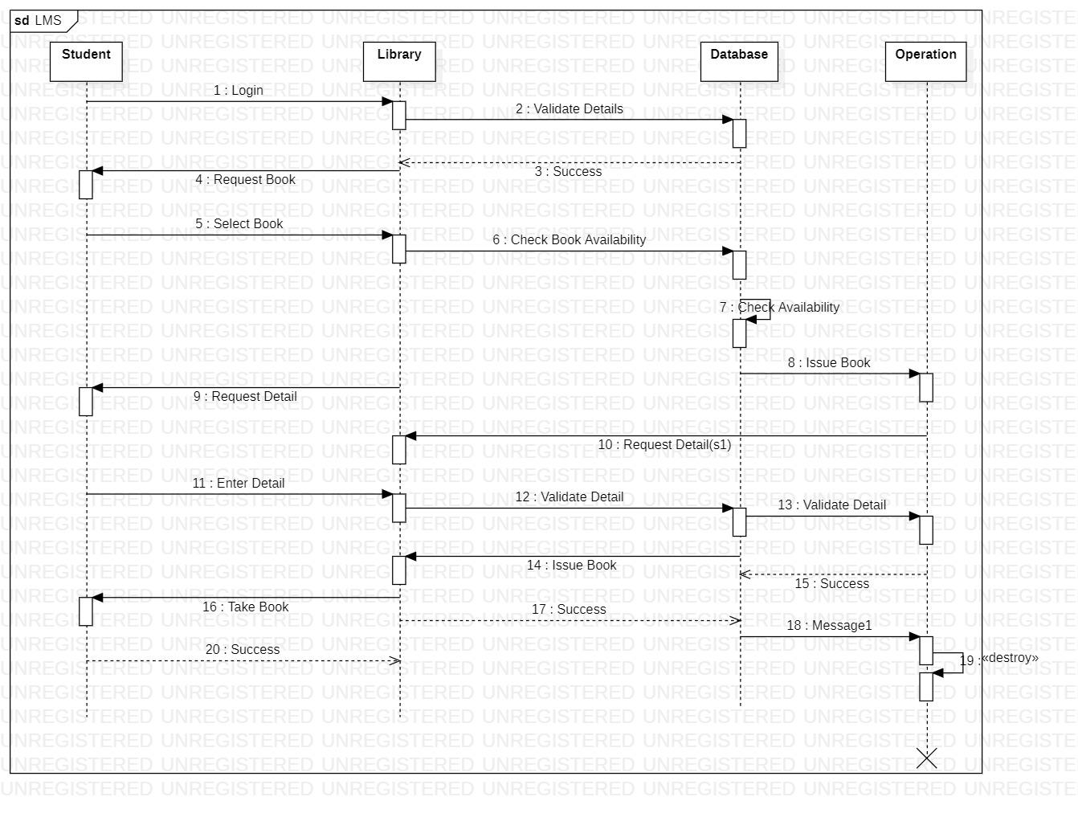

**Tutorial 6 - Data Flow Diagrams**

Create a Level 0 DFD for online shopping.

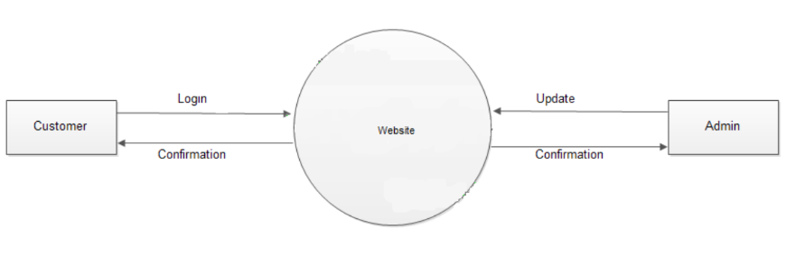

Create a Level 1 DFD for an online shopping system.

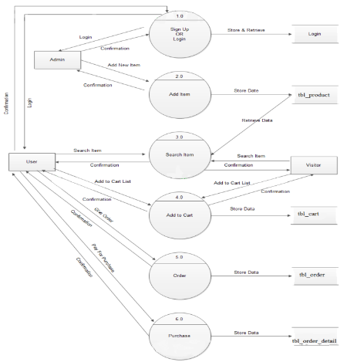

Create Level 2 DFD for online shopping system.

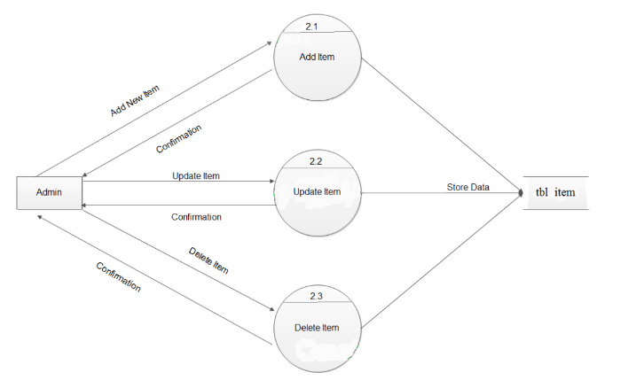

Create Level 3 DFD for online shopping system.

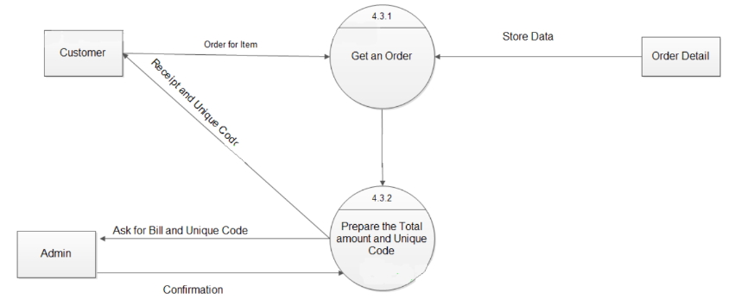

Create a Level 0 DFD for LMS.

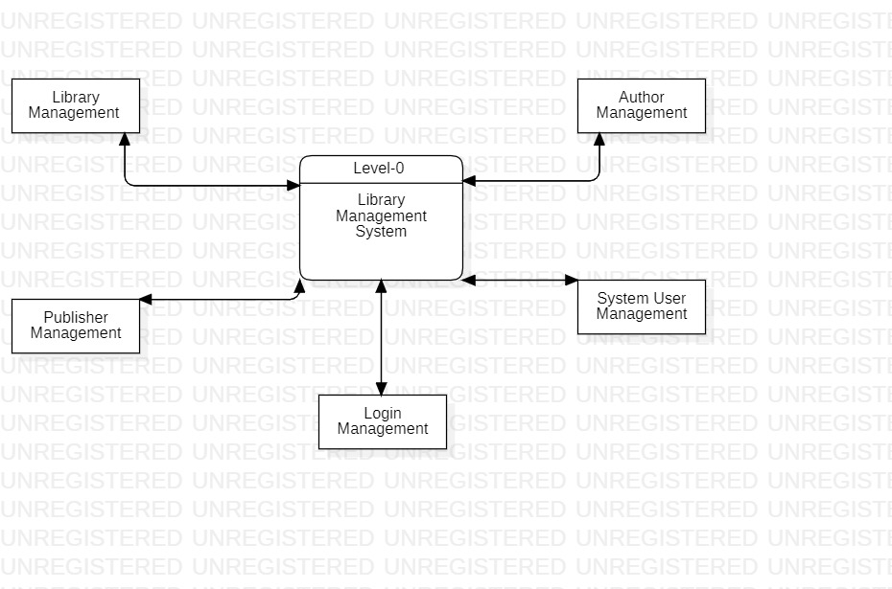

Create a Level 1 DFD for LMS.

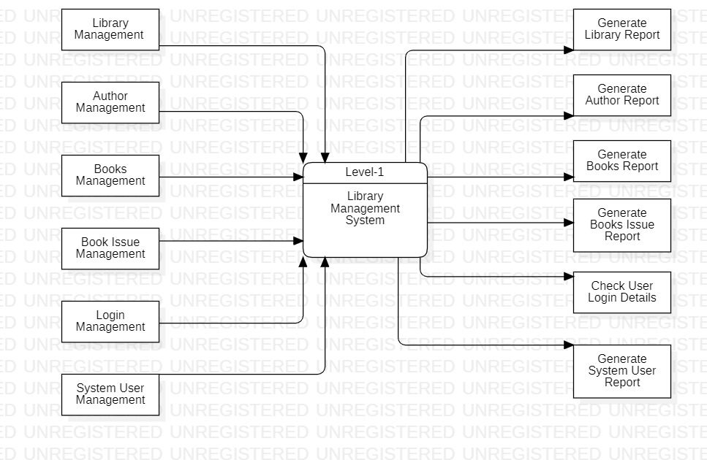

Create Level 2 DFD for LMS.

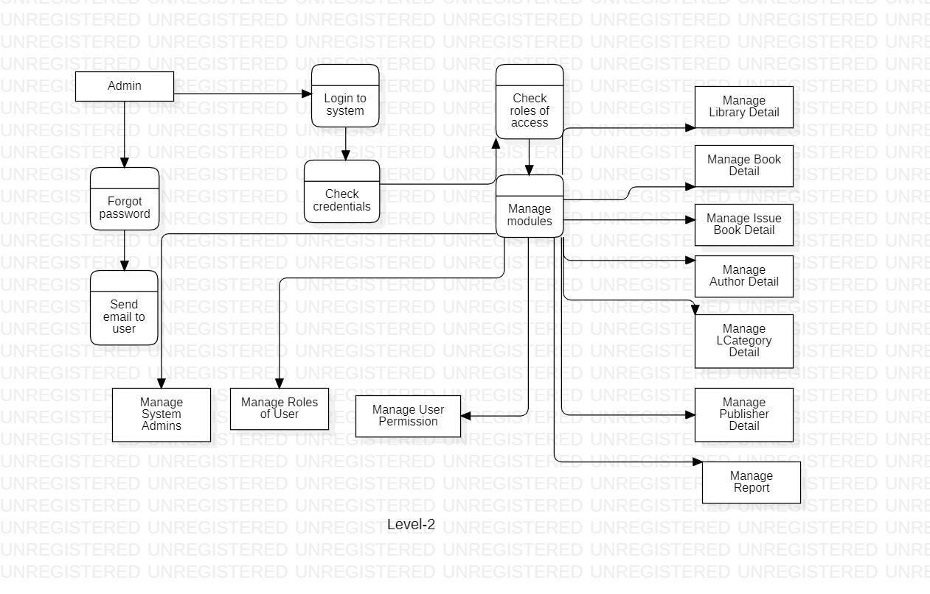

**Tutorial - 7:**

**Deployment Diagram**

1. **Draw Deployment diagram for library management system.**

**Ans.**

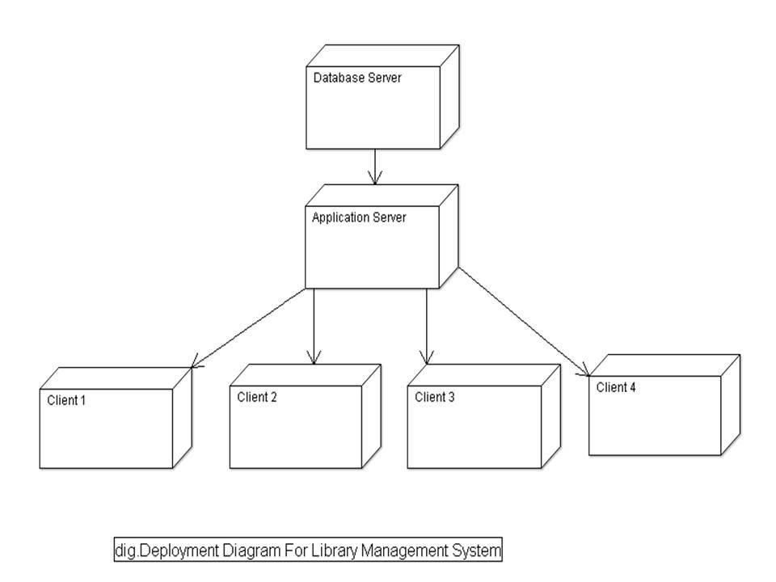

1. **Draw Deployment diagram for Online shopping system.**

**Ans.**

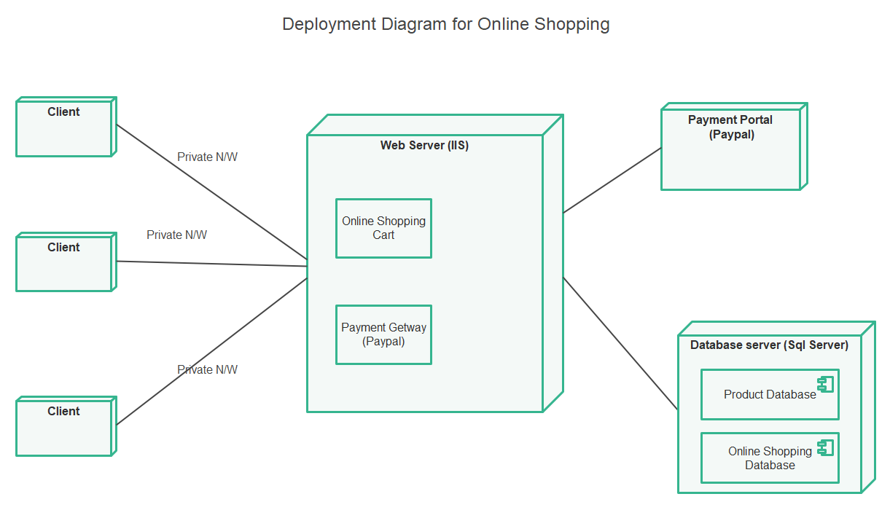

**Tutorial - 8:**

**Component Diagram**

1. **Draw Component diagram for LMS.**

**Ans.**

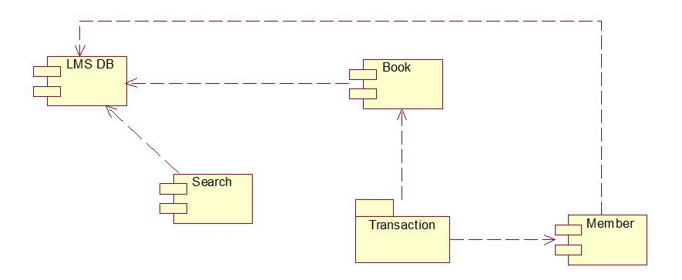

1. **Draw Component diagram for online shopping system.**

**Ans.**

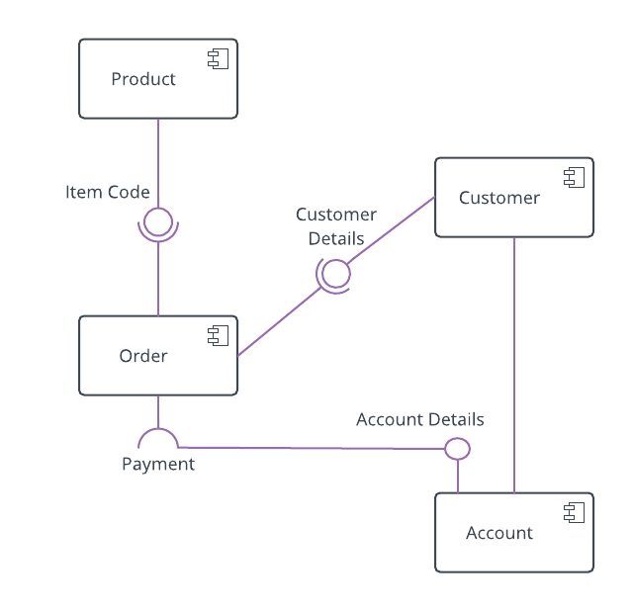

1. **Draw Component diagram for ATM system.**

**Ans.**

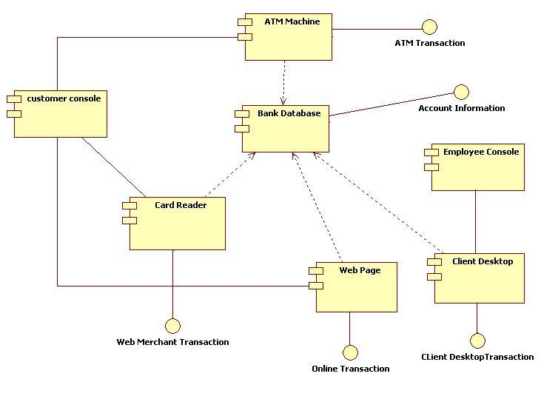

**Tutorial - 9:**

**Package Diagram**

1. **Draw Package diagram for Online shopping system.**

**Ans.**

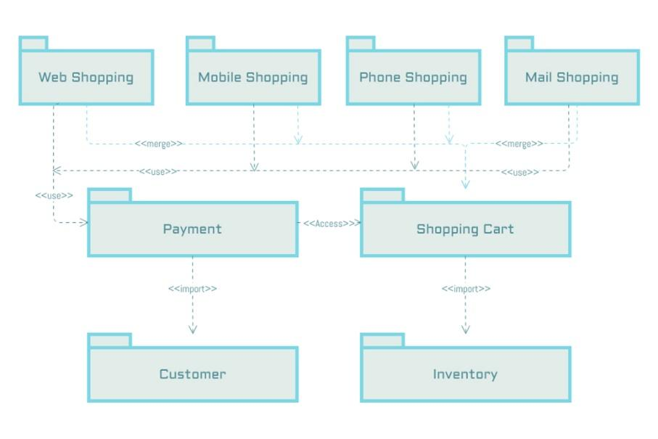

1. **Draw Package diagram for Hospital management system.**

**Ans.**

